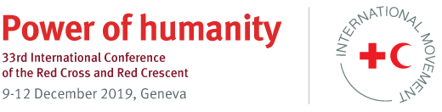

33rd International Conference of the Red Cross and Red Crescent

  - Resolution Reporting Form
(For your reference and internal use only. Please note that all reports need to be submitted via the online reporting form)

- Has your State/National Society/Institution incorporated the commitments contained in this resolution into the relevant strategic or operational plans?

Answer: yes/no.

If yes, which ones? (you can choose more than one option)
- Strategy
- Policy
- Operational plan / Roadmap
- Legislation (e.g. Law, Regulation, Statutes, Rules of Procedure etc.)
- Other (please explain)

At which level? (you can choose more than one option)
- International
- Regional
- National
- Local

Please provide details about how this has been done

- Has your State/National Society/Institution been working with other partners to implement the commitments contained in this resolution?

Answer: yes/no.

If yes, which partners? (you can choose more than one option).
- National Red Cross or Red Crescent Society in your country
- Government and/or public authorities
- ICRC/IFRC
- Other National Red Cross or Red Crescent Societies
- Humanitarian and development partners (e.g. UN, NGOs etc.)
- Academia
- Other
Please provide examples of your cooperation with partners

- Have you encountered any challenges in implementing the commitments contained in this resolution?

Answer: yes/no

If yes, what type of challenges? (you can choose more than one option below).
- Human resources
- Funding constraints
- Lack of leadership support
- Competing priorities
- Lack of specific knowledge/expertise
- Lack of capacity and/or support (technical, financial, or other)
- Other

Please provide details of these challenges

- Have the commitments contained in this resolution had an impact on the work and direction of your State/National Society/Institution?
Answer: Yes/ no

If yes, what type of impact? (You can choose more than one option)
- Cooperation between Government/public authorities and National Society has been strengthened
- Programming and operations have become more effective and efficient
- Innovative tools/methodologies have been developed and are utilized
- Partnerships with other humanitarian actors have been created or enhanced
- Increase in mobilization of resources
- Training and capacity of staff and volunteers has increased (for National Societies)
- Other

Please provide details about this impact:

- Have the commitments contained in this resolution had an impact on the communities that your State/National Society/Institution serves?

Answer: Yes/no

If yes, please briefly describe the impacts at community level

