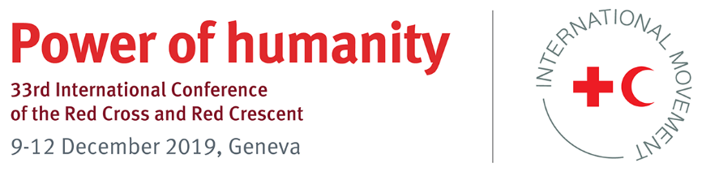

Pledge on prevention and response to sexual exploitation and abuse
and sexual harassment (SEAH) - Definitions

Definitions

- Abuse refers to neglect, emotional, physical and/or sexual exploitation and abuse and sexual harassment (SEAH) of any child, young person or adult by any member of our staff, volunteers and associated personnel.
- Community-based mechanism is a system which is rooted in community input so that the structure is both culturally and gender-sensitive, maximising its safety and effectiveness.
- Harm refers to unplanned negative impact on any child, young person or adult due to our operations, humanitarian assistance and/or protection.
- Sexual abuse refers to the actual or threatened physical intrusion of a sexual nature, whether by force or under unequal or coercive conditions, including sexual assault and rape. Sexual activity with any person under the age of 18 is considered to be sexual abuse, regardless of local legislation.
- Sexual exploitation refers to any actual or attempted abuse of a position of vulnerability, differential power or trust for sexual purposes, including but not limited to proﬁting monetarily, socially or politically from the sexual exploitation of another. It includes transactional sex, solicitation of transactional sex and exploitative relationships.
- Sexual harassment refers to unwanted conduct of a sexual nature, including verbal, non-verbal or physical conduct, which is, or might reasonably be, perceived as offensive or humiliating.
- Zero tolerance is a commitment to immediate operational response when a concern is raised and an obligation on any staff, volunteers and associated personnel to report concerns as soon as they arise. It includes protection of, and non-retaliation towards, whistleblowers or anyone else reporting concerns. Zero tolerance to SEAH includes a prohibition on transactional sex by aid personnel, regardless of local legislation.

