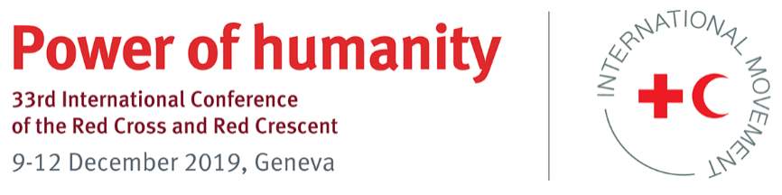

Model Pledge

Tackling epidemics and pandemics together

This model pledge provides some examples of possible statements and clauses to be used in specific pledges to promote specific actions for components of the International Red Cross and Red Crescent Movement (Movement) in their work with governments and communities to improve national preparedness and response to epidemics and pandemics. The pledges also support States’ efforts to strengthen core capacities under the World Health Organization’s International Health Regulations (IHR) (2005), where relevant.

This pledge has been developed to support the implementation of the proposed resolution of the 33rd International Conference of the Red Cross and Red Crescent, “Time to act: Tackling epidemics and pandemics together”.

It is not expected that every element suggested here will be included in every pledge. Furthermore, there may be specific pledges not presented here that National Societies and Governments may wish to make. Each National Society and Government can decide which clauses best suit their context, or they can use their own language.

Pledge for the period 2019–2023:

- Introduction
The purpose of the resolution is to support Movement components in implementing a structured, comprehensive, predictable and coordinated approach to epidemic prevention, detection, response and recovery, in close cooperation with States and other partners.

The resolution will facilitate the development of a common vision, approach and commitment for working together within countries and across borders to ensure the maximum impact of all investments in epidemic control. It will also facilitate successful detection, control and response activities, ultimately saving lives and building the health resilience of the most vulnerable people and communities.

We recognize that public authorities and National Societies, as auxiliaries to their public authorities in the humanitarian field, enjoy a specific and distinctive partnership, entailing mutual responsibilities and benefits based on international and domestic laws, in which the national public authorities and the National Society agree on the areas in which the latter supplements or substitutes for public humanitarian services within its mandate and guided by the Fundamental Principles.

- Suggested action plan
[Insert target date, such as, “By 2023, we will have made measurable progress in implementing the following actions”.]

The conference participant could commit to the following actions.
- The National Society offers support to its public authorities, as appropriate, in its efforts to strengthen core capacities as part of the obligations to comply with the IHR (2005).
- Consider including the National Society in the development and maintenance of national, intermediate and local, or primary response-level, public health emergency response plans for hazards.
- Build early warning and rapid response capacities in hard-to-reach, vulnerable, underserved and high-risk communities.
- Promote active community engagement in epidemic and pandemic prevention, preparedness and response, based on an all-hazard and whole-of-society approach.
- Promote and protect the physical, mental and psychosocial well-being of the people who respond to epidemics and pandemics.
- Contribute to emergency response operations during a public health emergency in line with the national emergency response plan with sufficient resources and capacities.
- Contribute to the development of evidence-based approaches to community-centric epidemic prevention and control, and the further development of innovative tools, guidance and strategies that improve the quality of response to epidemics and pandemics.
- Explore ways of prioritizing and investing in prevention and preparedness, and provide catalytic funding to support early action.

- Examples of indicators for measuring progress:
- The number of policies and/or procedures that are revised, to strengthen cooperation between States and the Movement in epidemic and pandemic risk management, is increased.
- The percentage of funding and resources that are allocated to community-led initiatives to reduce epidemic and pandemic risk is increased.
- The number of staff, volunteers and partners trained in epidemic control methods and practices is increased.
- The number of community-based epidemic surveillance systems is increased.
- Domestic emergency response legislation, and national policies, plans and coordination mechanisms are reviewed and revised in order to ensure epidemic and pandemic risk management are integrated in them.
- The National Society is invited to contribute to the IHR Joint External Evaluation (2005) and to engage in the continuous process of strengthening capacities for the implementation of the IHR.
- Additional funding is allocated in order to support both staff and volunteers in their training and work in epidemic control.

- Resource implications

Please indicate, as far as possible, the resources that may be required to support the implementation of this pledge.

State/National Society: __________________________________________________

Name of department and focal person: _____________________________________

Email address and extension no.:_______________________________________________

Model pledge proposed by the International Federation of Red Cross and Red Crescent Societies (IFRC).

For additional information, please contact: Panu Saaristo, Team Leader, Emergency Health, IFRC, panu.saaristo@ifrc.org

