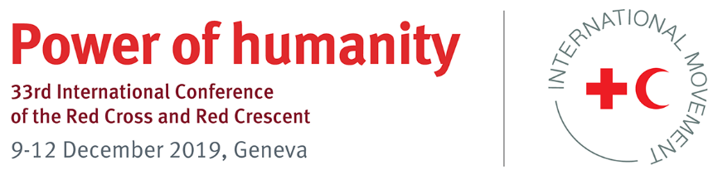

Model Pledge

Model pledge title

National Society development:
Strong and effective local humanitarian actors

Pledge for the period 2019–2023

- Introduction

Investing in local humanitarian capacity is a key solution to the growing humanitarian challenges we face.

National Red Cross and Red Crescent Societies (National Societies) are central to effectively responding to disasters, conflicts and protracted humanitarian crises because they are local actors, with 13.7 million volunteers on the ground almost everywhere in the world, that are there before, during and after crises. They directly deliver key relevant services to the most vulnerable in the communities in which they are rooted and contribute to stability at the local level.

Through the International Federation of Red Cross and Red Crescent Societies (IFRC) and the broader International Red Cross and Red Crescent Movement (Movement), these local actors are organized in a formidable global network that contributes to the global capacity to manage the risks and impact of disasters, emergencies and crises.

Many National Societies are sustainable, independent humanitarian organizations, recognized and credible in their communities, and trusted partners delivering effective services. Others need investment in order to grow and reach their full potential. Yet National Societies with limited capacities or in situations of continual instability can find it difficult to access the resources they need and struggle to mobilize investment for their organizational development.

Addressing such challenges requires a collective response from both States and Movement components in line with the Grand Bargain commitment to increase and support multi-year investment in the institutional capacities of local and national humanitarian responders.

- Objectives of the pledge
The objective of the proposed commitment is to increase support to National Societies for their development as strong, effective and principled local humanitarian actors.

- Potential actions for governments and National Societies

States and National Societies can develop their own action plans in accordance with the objectives they select and come up with their own time frame and list of measurable actions that they intend to implement by 2023.

The measures that States and/or National Societies choose to take in order to achieve the objectives may include the following:
- A government pledges to support the development of the National Red Cross or Red Crescent Society of its own country, in line with Article 2.2 of the Statutes of the Movement: “Each State shall promote the establishment on its territory of a National Society and encourage its development.”
This may include:
  - making resources (financial, human or others) available for the development of the National Society of its own country so that it can fulfil its mandate successfully
  - allocating a percentage of the annual budget as annual income for the National Society so that it can fulfil its mandate successfully, including the provision of services and disaster preparedness and response
  - facilitating access to resources through tax exemptions and specific legislation in this regard
  - facilitating tax exemption or tax deductibility for donations from individuals and/or companies to the National Society of its country
  - facilitating access by the National Society to funds generated by the government for non-profit organizations (such as the distribution of lottery proceeds).
- Governments (either on their own or together with the National Society of their own country) assist the National Societies of other countries, as a commitment to strengthening local actors, by pledging to support the National Society Investment Alliance (NSIA), the joint IFRC and ICRC funding mechanism investing directly in National Societies to support capacity development.
- A government supports National Societies from other countries by allocating resources to its own National Society’s international activities, specifically earmarked for National Society development, as a commitment to strengthening local actors.

Please select keyword “National Society development” for your pledge

Model pledge proposed by: IFRC National Society Development Coordination and Support (NSDCS) Unit, Policy, Strategy and Knowledge Department

For more information, please contact: Giorgio Ferrario, Manager, NSDCS, IFRC giorgio.ferrario@ifrc.org

The Localization Commitment reads: “Increase and support multi-year investment in the institutional capacities of local and national responders, including preparedness, response and coordination capacities, especially in fragile contexts and where communities are vulnerable to armed conflicts, disasters, recurrent outbreaks and the effects of climate change. We should achieve this through collaboration with development partners and incorporate capacity strengthening in partnership agreements.” (accessed at https://interagencystandingcommittee.org/more-support-and-funding-tools-local-and-national-responders)
The National Society Investment Alliance (NSIA) is an independent pooled-funding mechanism providing flexible multi-year financing and support for the development of National Red Cross and Red Cross Societies, strengthening their capacity to deliver humanitarian services within local communities. This includes a) support for organizational development, technical capacity development and increasing the effectiveness and sustainability of services in line with the mission of the Movement and its Fundamental Principles, b) strengthening leadership, governance and systems at all organizational levels within National Societies so that they are accountable and transparent, and c) increasing National Societies’ capacity to develop adaptive financial and business development strategies to generate diversified resources and enhance organizational sustainability.

