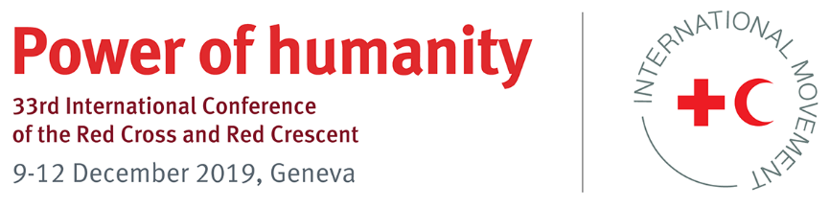

Model Pledge

Model pledge title: Model pledge on reducing the vulnerabilities of urban communities and contributing to safe and inclusive cities through principled humanitarian action

International Conference theme/topic(s) related to this pledge

Contributing to safe and inclusive urban communities through urban humanitarian action is the subject of one of the spotlight sessions under the Shifting Vulnerabilities Commission of the 33rd International Conference of the Red Cross and Red Crescent. This spotlight session aims to increase awareness about the underlying causes and manifestations of the varied risks and vulnerabilities that urban communities are facing and about the opportunities of urban environments. It also complements the Urban Warfare spotlight session to be held during the International Humanitarian Law Commission meeting.

Please select keyword “urban resilience” for your pledge

Pledge for the period 2019–2023

A) Introduction

Today, the urban population grows by roughly 1.4 million people every week, and forecasts indicate that it will constitute two-thirds of the world’s population by 2050 (United Nations). The UN estimates that 90% of the 2.3 billion more people on the planet by that time will be in developing countries in Asia and Africa, with most of the growth happening in small and medium-sized cities. Such urban growth forces the most vulnerable – including the urban poor, rural migrants, refugees and displaced populations – to settle in areas often identified as informal settlements or slums.

The communities living in these areas face multiple risks stemming from lack of access to basic services, exclusion from urban governance systems, violence, criminality and insecurity due to lack of land and property rights, education and sustainable income.

As the world urbanizes, so does armed conflict and violence, and this has profound implications for the protection of civilians and for the ability of humanitarian organizations (including National Red Cross and Red Crescent Societies) to operate effectively. The International Committee of the Red Cross (ICRC) estimates that some 50 million people are presently affected by armed conflict in urban areas and that urban warfare is likely to remain a reality for the foreseeable future.

Governments continue to bear primary responsibility for the security and wellbeing of their citizens. However, through its humanitarian action, the International Red Cross and Red Crescent Movement (Movement) also has a role to play. Partnerships and collaboration between National Societies, governments, international organizations, civil society, business and academia will be the only way forward to deliver results at scale and sustainably address the humanitarian needs of urban communities affected by conflict, violence and natural disaster.

B) Objective

The main objective of this model text is to inspire governments and Movement actors to reduce the risks and vulnerabilities faced by the urban poor and marginalized communities in cities and towns through concrete actions between now and 2023.

C) Suggested action plan

States and National Societies may select one or more commitments from the following sample list by checking [✓] the boxes as appropriate.

The signatories pledge to support and promote the Movement in:

- Increasing understanding of, and operational capabilities in, urban contexts by partnering with expert organizations and local stakeholders, particularly local authorities. This could include: (a) organizing dialogues between Movement actors and local authorities to identify and discuss ways forward to address specific humanitarian challenges in cities, and (b) integrating risks specific to disasters in urban settings into city- and community-level disaster preparedness and response mechanisms.
- Raising awareness about the adverse effects of disasters, climate change, violence and conflict on the most vulnerable urban communities.
- Strengthening organizational capacity and the auxiliary role of National Societies in urban disaster and emergency management systems to respond to urban disasters and conflict more effectively.
- Supporting Movement actors in identifying and developing locally responsive resilience programmes addressing, in particular, gender, community engagement and accountability, and humanitarian diplomacy. This could include fostering multi-stakeholder city alliances and coalitions to promote a culture of safety, social inclusion and solidarity in cities.
- Gaining access to urban communities – particularly those in hard-to-reach areas – in order to understand and effectively respond to their needs.
- Respecting humanitarian law and principles in the conduct of hostilities and use of force and avoiding the criminalization of humanitarian action under domestic legislation.

D) Indicators for measuring progress

- Increased number of policies, plans and strategies in urban areas that integrate risk, vulnerability and capacity assessments; disaster risk reduction; climate change adaptation; ecosystem management and restoration; and the Safer Access Framework
- Increased number of urban communities covered by disaster risk reduction programmes addressing, in particular, the effects of climate (change) and ecosystem degradation
- Increased number of urban communities who, by 2030, are covered by new or improved heat action plans that ensure that urban planning processes in cities consider heat risk reduction strategies
- Increased number of dialogues between Movement actors and local authorities (city level) to identify and discuss ways forward to address specific humanitarian challenges in cities
- Increased engagement of Movement actors with local authorities to ensure the continuity of essential urban services during urban warfare and violence
- Increased funding for long-term humanitarian protection and assistance activities in urban settings
- Increased number of good practice examples of Movement actors acting as a neutral intermediary between communities, local authorities and weapon bearers
- Increased number of urban volunteer programmes in cities
- Increased number of trained community-based disaster response teams

E) Resource implications

Please indicate, as far as possible, the resources that you may require to support the implementation of this pledge.

For more information, please contact
IFRC Senior Officer for Urban Disaster Preparedness, Aynur.kadihasanoglu@ifrc.org

