For the detailed information please find attached file
[Resolution 4] Health Care in Danger: Continuing to protect the delivery of health care together
1. Which measures have you put in place in order to enhance the secure functioning of health care facilities and medical transport?
- Conducting the workshop on Chemical, Biological, Radiological, and Nuclear co-hosted by ICRC and KNRC. There are 31 participants and it aimed for effective measures to protect the residents and how to act for relief efforts in the events of a fire prevention disaster.
 | 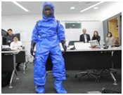 | 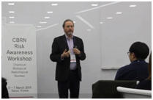
〈How to response to CNRN> | 〈Drilling for wearing protect gear> | <Training>
- KNRC has renovated the blood donation bus to enhance the safety
of blood donors and nurses.
2. Which concrete actions have you conducted to collect and analyze data related to violence against health care? How did you use this information to develop practical measures to address such violence?
3. What decisions have you taken to enhance your staff and volunteers’ understanding of the rights and responsibilities of health care personnel? In addition, have you implemented concrete measures (e.g. Safer Access Framework) to ensure the safety of health care delivery?
- KNRC attend Asia Pacific Roundtable on Safer Access held on
June, 2019 and the participants shared the knowledge with staff. In order
to be in line with, its contents of Safer Access, KNRC is working
on the creating of check list to enhance the safety of volunteers.
4. As an auxiliary to your government, which activities have you initiated to promote, advocate for, and address the issue of violence against health care with your government?

