32nd IC – Resolution unique questionnaire – British Red Cross

 | Health Care in Danger: Continuing to protect the delivery of health care together
1 | Has your organisation taken action on the implementation of this resolution?  Yes
2 | If YES, please describe the actions taken (including challenges encountered if there is any) and provide concrete examples (including written reports, programme information, photos and videos*)  3 key facts and figures  - The topic of Health Care Delivery in Armed Conflict was included in papers on the Promotion and Implementation of International Humanitarian Law, prepared by the British Red Cross and the ICRC for consideration at both the Commonwealth’s Law Ministers Meeting (16-19 October 2017) and the Commonwealth Meeting of Senior Officials of Law Ministries (1-3 October 2018).  - On 19 April 2018, the NGO – Military Contact Group (NMCG), which is chaired by the British Red Cross, held a meeting to answer the following question: Are all Humanitarian Principles equal in the delivery of frontline humanitarian medical care? Using the case example of the World Health Organisation’s (WHO) co-location of civilian medical teams alongside the Iraqi military, during the 2016-2017 military campaign, Battle of Mosul, Iraq, as a discussion starting point, the meeting set out to explore the extent to which the Humanitarian Principles of Humanity, Neutrality, Impartiality and Independence, can be adhered to when humanitarians work in situations of close proximity to the military to deliver frontline medical care within an active conflict setting. Further, the discussion examined whether all four Humanitarian Principles could be up-held equally or whether compromises should be afforded as to the weight of individual Principles, in order to effectively deliver live-saving care. Currently, the case example of Mosul is deemed as unique, however, it is acknowledged that with the changing and increasingly complicated nature of conflicts that these questions will continue to arise and could become a ‘new norm.’  - On 1 February 2018 and 28 January 2019, a British Red Cross international law adviser gave a lecture at University College London on the treatment of the medical function under IHL and the legal bases of humanitarian action in armed conflict for a course on “Conflict, Humanitarianism and Health”. Additionally, on 7 February 2019, another adviser gave a lecture at St George’s University London on the same topic for the Wilderness and Disaster Medicine Society.  - On 2 November 2017, an international law adviser gave a presentation at the Queen Alexandra’s Royal Naval Nursing Service Symposium on the special status of the medical function under international humanitarian law with reference to how obligations under IHL can intersect with medical ethics more generally. The adviser also presented on humanitarian principles and the work of the International Red Cross and Red Crescent Movement.  - On 7 April 2018, an international law adviser gave a lecture on Legal and Ethical Issues in Armed Conflict Situations for the Society of Apothecaries’ course on Conflict & Catastrophe Medicine.  - The British Red Cross sent a Technical Team Manager to the Geneva Reference Group on Global Health in May 2019. The debate at this meeting included a session on safety, security and protection of humanitarian health care actors in the context of conflict and violence.  - The British Red Cross Executive Director for International, Alexander Matheou visited Yemen in April 2019 and briefed the All Party Parliamentary Group on Yemen shortly thereafter. Key themes of his briefing included safe access for humanitarian organisations including healthcare staff and respect for the IHL principles of precautions and proportionality.  2 high resolution pictures with an extended caption  Photographer: Yemen Red Crescent  British Red Cross director of international Alexander Matheou meets with paediatrician Dr Faysal at Al-Thawra Hospital in Sana'a in Yemen.  The International Committee of the Red Cross (ICRC) provides the hospital with medical equipment and supplies, and funds the refurbishment of the hospital's surgical wards.  The ICRC has also supported the hospital by maintaining previously donated generators, installing a new morgue, ensuring safe access to water while rehabilitating the well, and rehabilitating the water and sewerage networks of three hospital buildings.  The hospital is the biggest in Yemen with 900 beds but is still often overwhelmed with patients. It is estimated that only 50% of Yemen's healthcare facilities are functional.  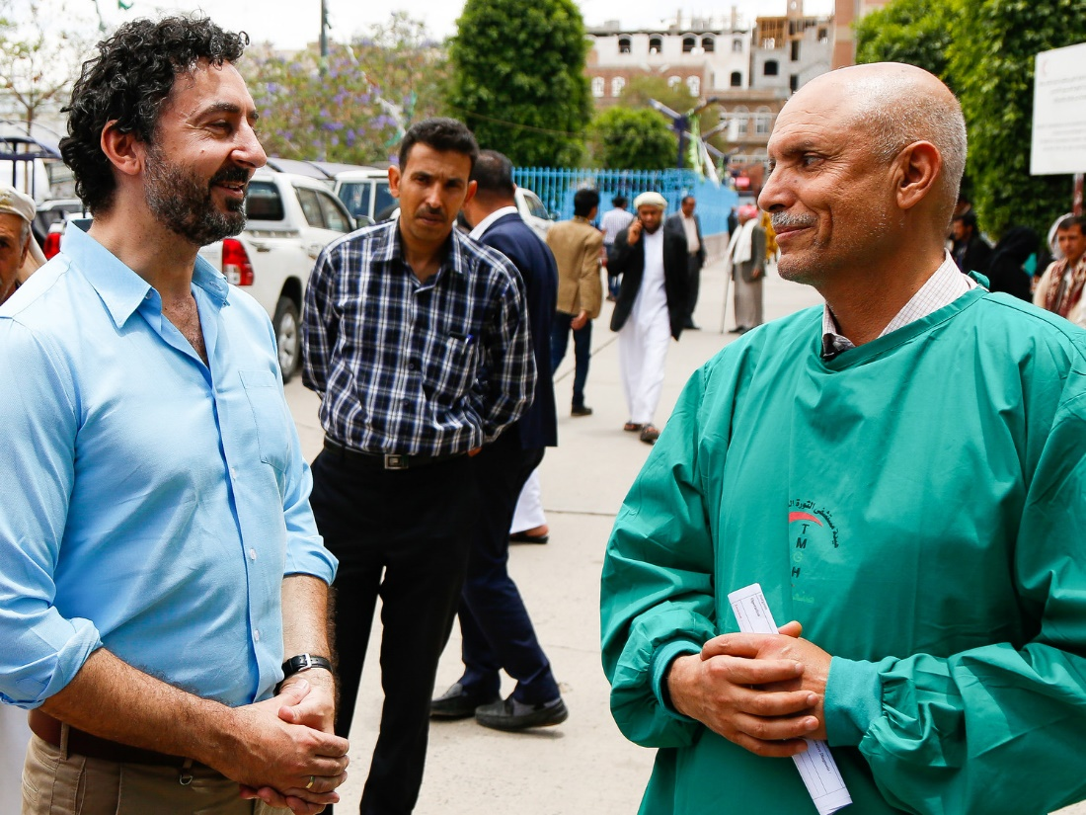  1 story of interest  On 16 May 2019, the International Law Programme at Chatham House, with the support of the British Red Cross, hosted a panel discussion on the protection of the wounded and sick in armed conflict, which also included a discussion of challenges to the protection of medical care and of health providers. This meeting was the first in a series of three to commemorate the 70th anniversary of the 1949 Geneva Conventions, and the panel consisted of expert representatives from Geneva Call, Médecins Sans Frontières, the ICRC and academia. Approximately 40 people attended the event, including former senior medical officers from the UK armed forces, senior Ministry of Defence (MOD) and Service legal advisers, Foreign and Commonwealth Office (FCO) and Department for International Development (DFID) officials, NGO personnel and academics. Reactions to the panel during the subsequent drinks reception were uniformly positive, with appreciation expressed for the forthright accounts of the speakers of the challenges faced in the work of their respective organisations. The Chair, Ms. Elizabeth Wilmshurst, opened the session by thanking the British Red Cross for generously supporting the series of meetings to be held at Chatham House to celebrate the 70th anniversary of the 1949 Geneva Conventions.  The session led to the discussion of several issues regarding the protection of medical care-givers in armed conflict, including the fact that there is still a debate on the margins of the law regarding who qualifies as medical personnel and when they may lose protection. Not every medical practitioner qualifies as ‘medical personnel’ under IHL. Rather, they must be assigned as medical personnel by one of the parties to the conflict. However, would State-employed health providers be the only practitioners entitled to protection as ‘medical personnel,’ or might protection also be extended to those in private practice or the assigned medical care-givers in non-State armed groups? The discussion demonstrated that the protections granted under IHL are still very much needed, but the non-international nature of many contemporary armed conflicts raises new questions and challenges for IHL regarding the protection of the wounded and medical care-givers.  The complete audio of the event can be found at https://www.chathamhouse.org/event/protection-wounded-and-medical-care-givers-armed-conflict-law-job.  Possible challenges  Given the high-profile role of volunteers, their presence in conflict environments and the perception that they hold political allegiances, which may place them at risk, and given their primary role in the Red Cross and Red Crescent Movement (specifically in more remote or conflict-affected areas), it would be helpful to acknowledge their unique challenges explicitly in future discussions and resolutions related to Health Care in Danger.
3 | If NO, please explain why and describe challenges encountered.  N/A
Please click here if the implementation is completed

Check yes

